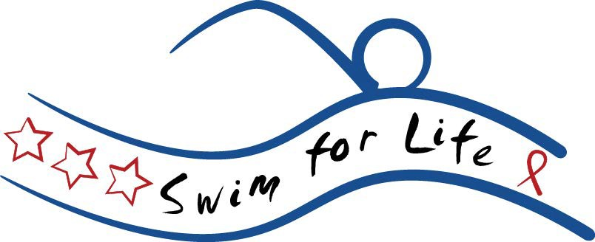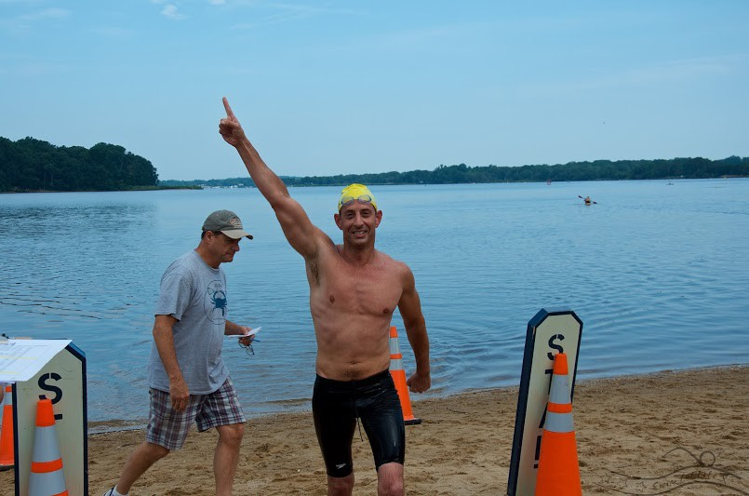
2.4 Triathlon Challenge Swim

September 19, 2020
Rolph’s Wharf MD
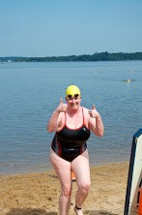
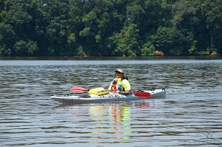
29th Annual Maryland Swim
for Life

Sanctioned by Potomac Valley LMSC for USMS, Inc., Sanction No. 100-W002 Sanctioned by USA Swimming XXXXXX

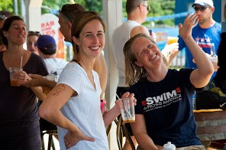
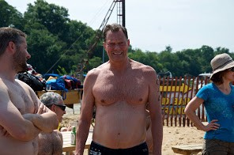
+
Maryland Swim for Life.
Register online today.

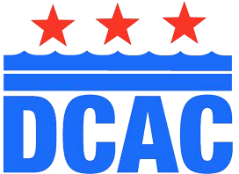
The District of Columbia Aquatics Club (DCAC) (https://www.swimdcac.org) is proud to host the 29th Annual Maryland Swim for Life on Saturday, September 19, 2020. DCAC is one of the largest United States Masters Swimming teams and is a 501(c)(3) organization. Proceeds from Swim for Life support local nonprofit organizations whose mission statements include environmental, medical, health, wellness and fitness advocacy.
REGISTER ONLINE AT:
https://www.swimdcac.org/

CLICK On
“Maryland Swim for Life”

REGISTRATION AND FUNDRAISING
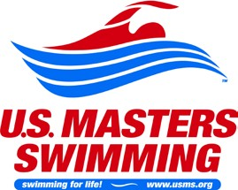
The registration fee for Swim for Life is $40. With your registration fee, you will receive breakfast, a picnic lunch, a swim cap and a t-shirt at Rolph’s Wharf on race day. We strongly encourage swimmers to register for Swim for Life though Club Assistant, which allows you to reach out to family and friends and collect donations online. Club
Assistant will also confirm your USMS registration or allow you to purchase your one-event USMS registration (“OEVT”) if you are not USMS- registered. Online registration will close at 11:59 pm eastern daylight time on Thursday, June 4, 2020.
We will still accept race-day registrations if you are unable to register online.

TRAINING/ELIGIBILITY
All swimmers must be registered with USMS to participate in this swim. USMS registration is easy to do online at www.usms.org/join. One-event USMS memberships are available for a fee of $30 during online registration. All swimmers are urged to train for this event, and novices are urged to enter the shorter distance waves (see schedule for required completion timing). All swimmers, “seasoned” and new, are welcome at this wonderful event.

+
where and
when

A day of fun and friendship - all for a great cause.

SCHEDULE
LOCATION
This year’s event will again take place at Rolph’s Wharf Marina on the Chester River, three miles south of Chestertown in Kent County. This beautiful setting, near a charming small town, is well worth a day trip or a weekend of exploring.
DIRECTIONS
From the Chesapeake Bay Bridge: Take 50 East to 301 North. 50 East and 301 North separate approximately 9 miles past the Bay Bridge. Stay on 301 by taking the left fork. In approximately 5 miles, take the Route 213 North exit toward Chestertown and Washington College. After 2 miles, you will pass through Centreville. Proceed another 10 miles and turn left onto Rolph’s Wharf Road. A Swim for Life banner will mark this turn. Follow Rolph’s Wharf Road for 2 miles and a volunteer will direct you for parking. If you plan to drive Saturday morning, it is best to leave early to avoid summer bridge traffic.

WATER
Water temperature on swim mornings is usually in the mid-70s. Wetsuits are allowed but will be scored separately (most swimmers do not wear one as the water is very comfortable); flotation devices (e.g., pull buoys, paddles, fins) are not. USMS regulations prohibit wetsuits if water
temperatures exceed 78 degrees.
7:00 – 8:15 a.m. On-Site Registration (check-in) and Breakfast

8:30 a.m. Opening Ceremony and Swimmer Instructions

9:00 a.m. Swim Start

12:30 p.m. Swim Cutoff; Picnic Celebration
and Awards Ceremony

Every swimmer must be registered and checked-in by 8:15 a.m. on race day. All pledge money not submitted online is also due by 8:15 a.m., in order to be included in fundraising totals used to determine prizewinners. ABSOLUTELY NO changes to race distance will be permitted after registration closes. To ensure the validity of the swim results, no mid-course changes are allowed, except for safety reasons. If you do not complete your designated distance, you MUST inform the event coordinators. During check-in, swimmers will be body-marked and capped according to distance and will receive a timing chip on a Velcro strap, to be worn around one ankle.

SAFETY
Safety support at the swim will be provided by the
U.S. Coast Guard and their Auxiliary, Maryland Natural Resources Police, the Chesapeake Paddlers’ Association, the Chester River Association, the Kent and Queen Anne’s County Rescue Squad, Chesapeake Bay Boston Whalers Club, and other local volunteer boaters and kayakers. There are no lifeguards on duty – participants and guests swim at their own risk.

+
2020 Swim for Life Swimmer Instructions
HAVE FUN, RELAX, ENJOY EACH OTHER, THE DAY, AND THE RIVER!
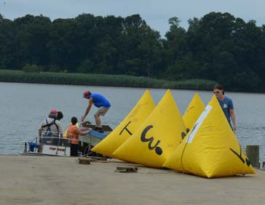
COURSE
There will be 2 large inflatable yellow buoys on the course-one at the start, one at the turnaround. See map. Each wave will turn around at that buoy which marks the halfway point of their swim. The Triathlon Challenge buoy, at .6 miles from the start, will be marked with a special orange buoy. All swimmers will start the swim in the same direction – up river (North). Upon reaching the appropriate buoy, swimmers will go around that buoy and swim back down river (South).

Swimmers should always keep buoys on their RIGHT going NORTH. Swimmers should always
keep the buoys on their RIGHT going SOUTH. Kayakers will be there to be sure you swim to the correct side. This prevents unfair shortcuts due to the curve of the river.

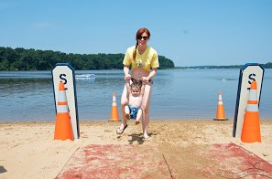
START PROCEDURE All swimmers must wear a timing chip on a Velcro strap around the ankle. Swimmers will start in the water, in 5 waves according to distance: 7.5K swimmers first, followed by 5.0K swimmers, then 2.4 milers, 2.5 kilometer swimmers and 1.2 milers last. Each group will begin 5 minutes after the preceding group has started.

SAFETY BOATS
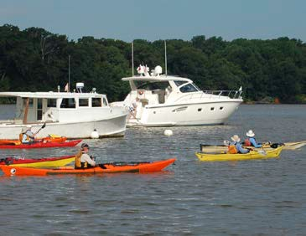
For your safety, USCG and NRP patrol boats are located near 3 locations: start/finish, half- way along the 1.25K course. Paddlers in kayaks and paddleboards will be stationed at all turn buoys and along the outside length of the course. Volunteer powerboats will also patrol swimmers along the course. Kayakers and paddleboards will keep swimmers on course, provide swimmers food and drink, act as a buffer between swimmers and boat traffic, and be available for water assistance. A local rescue boat with medic/dive personnel will also be on hand.

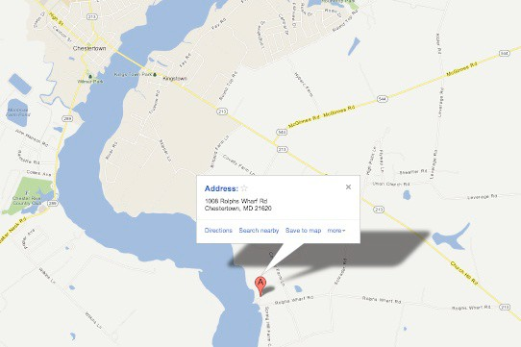
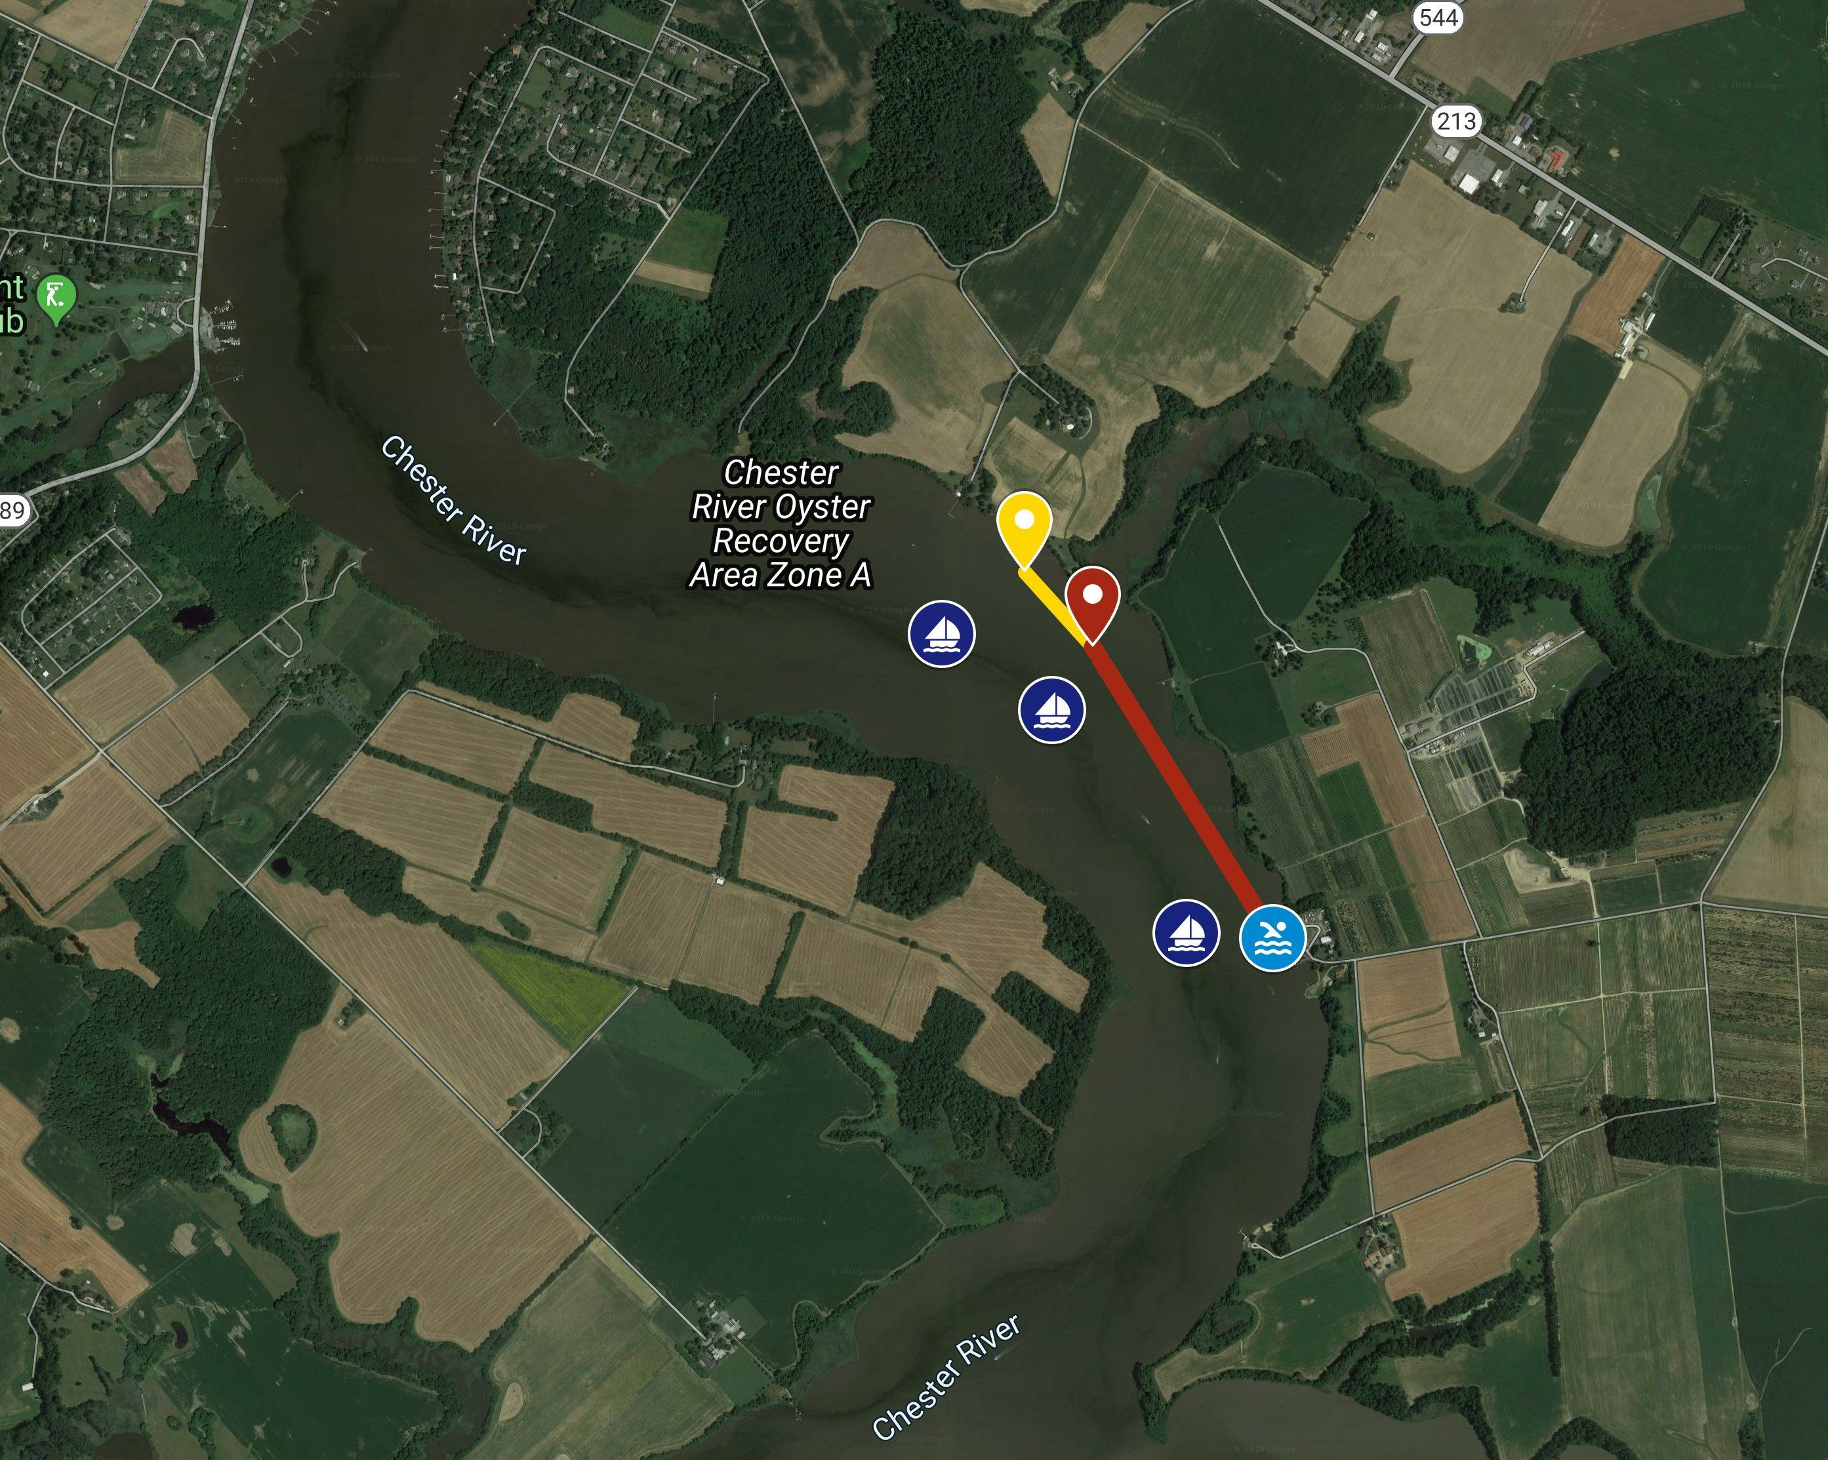

The Course.

Rolph’s Wharf Marina
1008 Rolphs Wharf Rd. Chestertown, MD 21620

Participants will start and finish at Rolph’s Wharf, in five waves by distance (7.5K starts first). The swims are out (upriver) and back (downriver) and run parallel to shore. Course map and swimmer instructions attached. The course is marked by inflatable yellow buoys at the start and turnaround. The triathlon swims buoy, at .6 miles from the start, will be marked with a special orange buoy.
Swimmers should always keep the buoys to their right. Water safety officials have the authority to determine when a swimmer needs to be removed from the water. Any swimmer removed from the water must report immediately to the DNF Official and recording station upon returning to shore. The swim ends promptly at 12:30 pm. Any swimmer still in the water at that time will be picked up by safety personnel and brought to the DNF pier.

A more-detailed interactive map of the course is available online at:

https://www.swimdcac.org

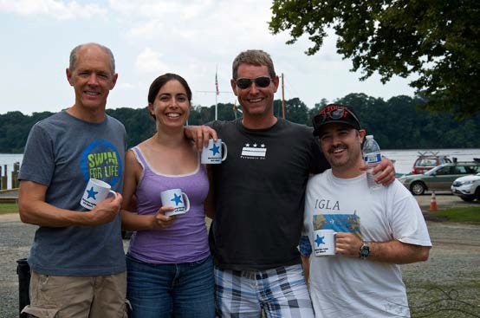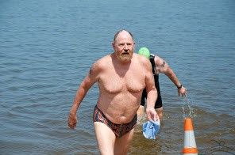

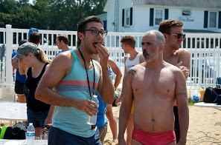
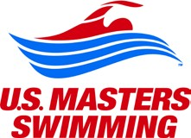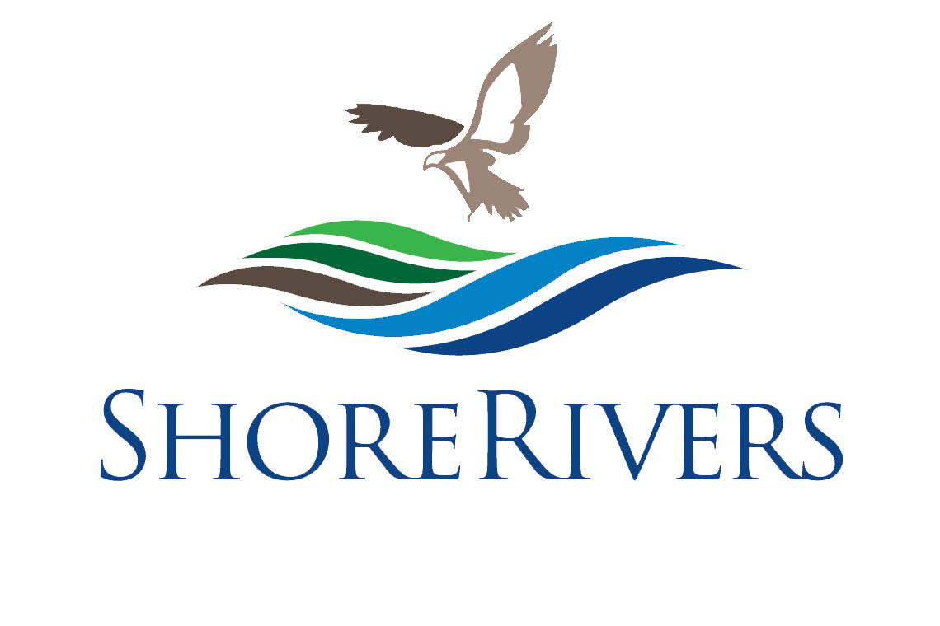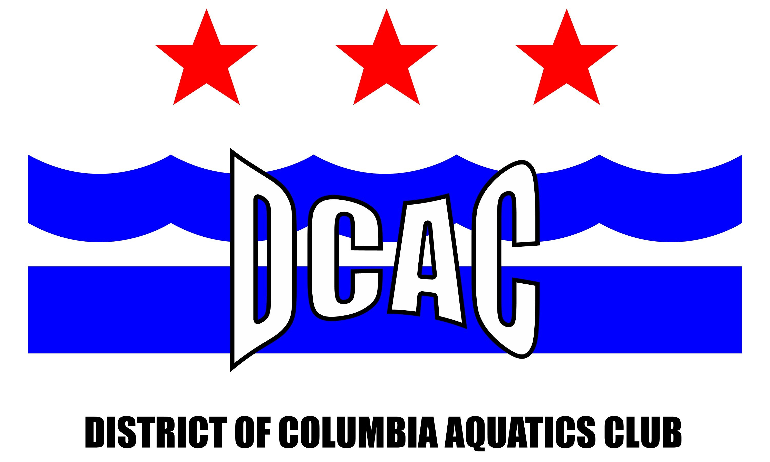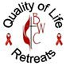Pledges.
Making a difference across our community.

Swim for Life’s purpose is to raise funds for our community. Each swimmer must contribute a minimum of $100 in pledges; many swimmers raise far more. Special prizes will be awarded to the top 10 fundraisers, based on pledges submitted by the start of the event. When you register online, you can submit your minimum pledge, and/or you can direct your sponsors to the online donation option. Pledge checks can be made payable to “DCAC Swim for Life.” Donations are tax-deductible.

Awards:
The top finishers, male and female, in 18-30, 31-45 and 46 & Up age categories for each distance will receive awards.
CHARITY PARTNERS:
Donations are distributed to:

Heart to Hand, Inc.
- Shore Rivers
- Quality of Life Retreats
- District of Columbia Aquatics Club
Find out more about our charity partners on our website: https://www.swimdcac.org/
Click on "Maryland Swim for Life"

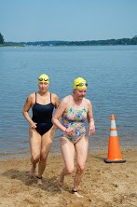
+

September 19, 2020
Rolph's Wharf
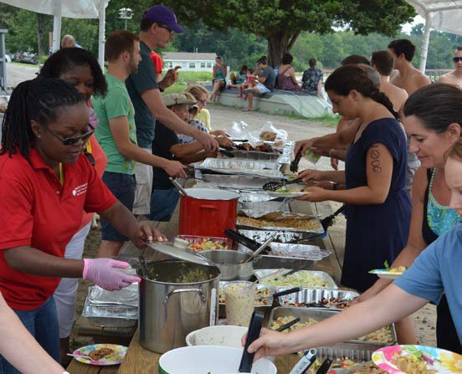
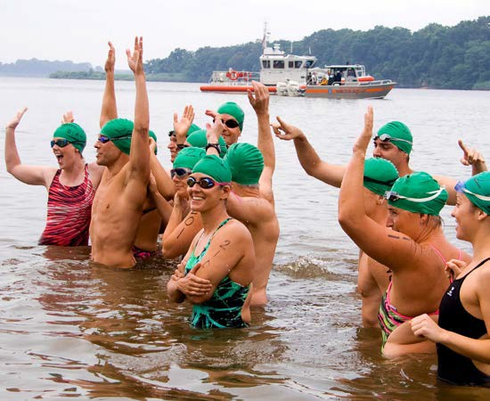
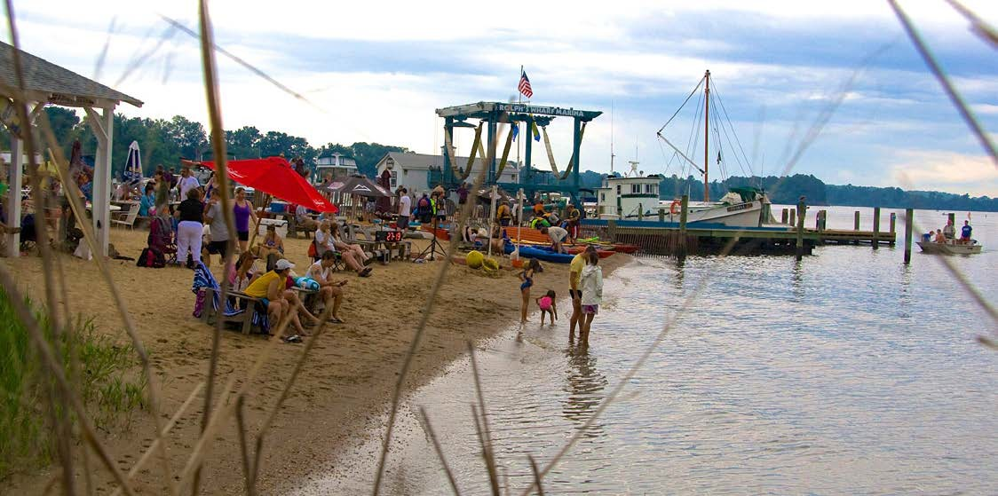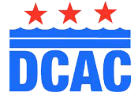

Contact Information:
For additional information, please email swimforlife@swimdcac.org
or call Brent Smith 213-999-7946 or treasurer@swimdcac.org or call Kevin Majoros at 410-382-7205

Last minute updates and information will be posted on the Swim for Life website and facebook:
https://www.swimdcac.org
Click on Maryland Swim for Life

