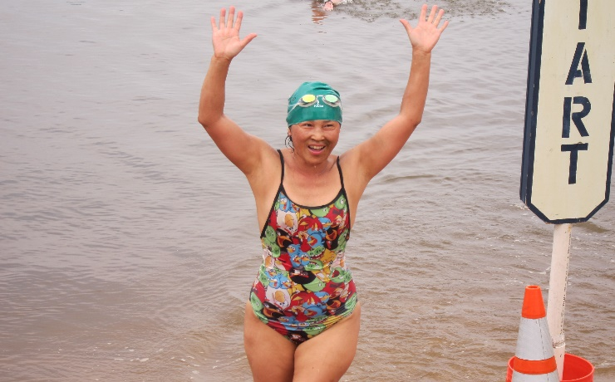
28th Annual Maryland Swim for Life!
July 13, 2019
Sanctioned by Potomac Valley LMSC for USMS, Inc., Sanction: 108-W002

The District of Columbia Aquatics Club (DCAC) is proud to host the 28th Annual Maryland Swim for Life on Saturday, July 13, 2019. This will be our 18th year of hosting this community fundraiser! We invite all swimmers, old and new, to join us in participating in this wonderful event.
Proceeds from Swim for Life support four local nonprofits to help them in fulfilling their mission statement.

Swim: We are offering a 1, 2, 3, 4 & 5 mile swims along with a 2.4 mile triathlon challenge.
Pledges:
Each swimmer must contribute a minimum of $100 in pledges; many swimmers raise far more. Special prizes will be awarded to the top 10 fundraisers, based on pledges submitted by the start of the event. If you register online, you can submit your minimum pledge online and/or you can direct your sponsors to the online donation option. Pledge checks can be made payable to “DCAC Swim for Life.” Checks, cash, Venmo and credit cards will be accepted on the day of the event.
Funds raised are distributed to our charities: ShoreRivers, Heart to Hand, Quality of Life Retreats and DC Aquatics.

Registration and Fundraising:
The registration fee to swim in the event this year is $40. This is to offset some of the costs without using donations that would otherwise go to the charities. With your registration fee, you will receive breakfast, picnic lunch, a swim cap and a t-shirt. We strongly encourage swimmers to register for Swim for Life though Club Assistant, which allows you to reach out to family and friends and collect donations online. Club Assistant will also confirm your USMS registration or allow you to purchase your $30.00 one-event USMS registration (“OEVT”) if you are not USMS-registered.

Schedule:
Every swimmer must be registered and checked-in by 8:15 a.m. on race day. All pledge money not submitted online also is due by 8:15 a.m., to be counted towards determination of fundraising prize winners. ABSOLUTELY NO changes to race distance will be permitted after registration closes. To ensure the validity of the swim results, except for safety reasons, no mid-course corrections will be allowed. If you do not complete your designated distance, please inform the event coordinators. During check-in, swimmers will be body-marked and capped according to distance and will receive a timing chip on a Velcro strap, to be worn around one ankle.

Online registration closed at 11:59 pm eastern time on Thursday, July 11, 2019. We will still accept the 2018 Race Day Registration form (.pdf) if you are unable to register online. We cannot guarantee availability of t-shirts for registrations made after June 30, 2019.

