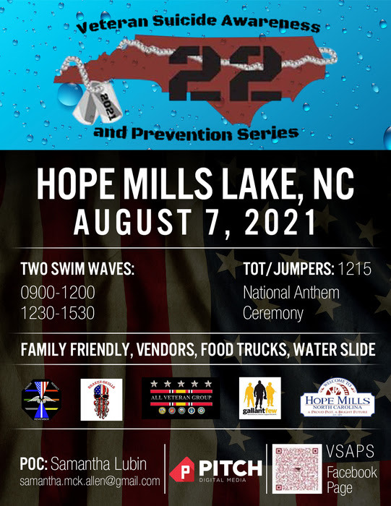

August 7th, 2021:
Veterans Suicide Awareness and Prevention Swim
_____________________________________________________________________________________
First, thank you so much for signing up for such an important event and cause! My team and I are so thankful to have you on Saturday, August 7th.
Please see below for some notes on the event. Make sure to encourage family and friends to come as there will be a sky diving demonstration during the official ceremony starting at noon and plenty of activities for the kids!

Race Location: Hope Mills Lake, NC
(If struggling for address via Google Maps put the following address in: 3609 N Main St, Hope Mills, NC 28348)

Packet Pick-up Info:
Packet pick-up will be separated into two waves: 0900-1200 and 1230-1530. Please see the timelines below according to your chosen wave. Please have your ID available to receive your packet. Upon check-in, you will receive pre/post-race snacks, a cap, and a medal (upon finishing).

Timeline for Wave #1:
- Wave #1 Check in: 0800
- Wave #1 Safety Brief: 0845
- Wave #1 Start Time: 0900
- Wave #1 Complete: 1200
- Official Ceremony Begins: 1205
Timeline for Wave #2:
- Wave #2 Check in: 1100
- Official Ceremony: 1210
- Wave #2 Safety Brief: 1225
- Wave #2 Start Time: 1230
- Wave #2 Complete: 1530

Timing:
This is an unsanctioned event. Do not expect to receive a timing chip upon check-in.
Race Day Info:
Parking: The entirety of N Main Street in Hope Mills will be closed between 0700 and 1600. There will be volunteers and police show you the parking. See the attached map for further guidance.

Disabled Parking: If you need assistance, please state that you need assistance and you will be shown to the First Citizens’ Bank for specialized parking.

Body Marking: You will mark your number on both of your arms as to be checked in and out of the water.

Caps: Caps are mandatory to wear during the entirety of the swim. This is for your safety and our fire and rescue teams to be able to always see you clearly.

Water Temps: Water temps will be posted on the Facebook page by 9:00pm on Friday before the event. NO WETSUITS WILL BE ALLOWED.
If the temperature dramatically drops in the lake, then the race committee will reconsider. However, at this time, because of the month and the temperature of the lake, no swimmer will be permitted to wear wetsuits for safety reasons.

Open Water Swim Tips:
If you need assistance during the swim, roll over on your back and put your hand in the air.
If you need to hang on to a watercraft during the swim, please make sure you are not hanging on to one of the motorized safety boats. You may hang on to a non-motorized vessel (kayaks, canoes, or paddleboards). Only in cases of emergency, may you grab onto a motorized boat.
When you hear three loud blasts of an air horn, immediately stop swimming and look up. Head to the nearest buoy, kayak, or boat to receive further instructions. This will be done only in cases of Emergency.

Disqualifications:
There will not be any reasons for “disqualifications” as this is a non-sanctioned event. The goal is to come out, enjoy the swim, and raise awareness for such an important cause.

Aid Station:
There will be an aid stationed manned and operated by the Hope Mills Fire Department by the boat launch.

