New Year Kick Off at
Kennesaw State
January 26th, 2019: Warm-up: 12pm Meet Start: 1pm

Host: Kennesaw State University

Officers: President: Lindsey Ballard
Vice President: Joe Kauffman
Meet Coordinator: Sam Laegan
Treasurer: Greyson Beckman
Secretary: Lindsay Saul
Social Coordinator: Katie Miller

Email: ksuswimclub@gmail.com

Location: Dr. Betty L. Siegel Student Recreation and Activities Center
290 Kennesaw State University Road, Kennesaw, GA 30144

Facility: Meet format is short course yards. The competition will be held in an 8 lane, 25 yard short course pool with lane 8 being used for warm-up and warm-down throughout the meet.

At the front desk you will need to submit your waivers and may be asked for a valid student ID. Please enter the pool deck through the locker rooms. There will be seating on the basketball courts right next to the pool for teams to set up since the deck is small.

Format: All events will be timed finals. These times will count for Nationals.

Swimmer
Eligibility: Must be a member of their respective swim club
Rules: Rules will be in accordance with USA Swimming rules. Complete rules can be found at www.usaswimming.org and will be available at the meet.
Entry
Procedure: Entries can be submitted in Hytek form or an excel spreadsheet. Entries should be sent to the above email with the club name and contact information.

Entry Fees: $15 per swimmer with a $300 cap for each team as a whole. Cash and checks will be accepted with checks made out to KSU Swim Club. Invoices will be sent out by our treasurer from the above address.

Deadline: All entries must be received by Sunday January 20th at midnight

Entry limit: Swimmers will be limited to 4 individual events and unlimited relays

Misc.: The presidents meeting will be at 12:45pm in the lifeguard room

There are bleachers on the pool deck but as stated before we are going to have the basketball courts so bring chairs if you desire.

There is no food or drink allowed on the pool deck and no deck changing.

Parking

East Deck: Located directly behind the Rec Center. It is free parking on weekends. If you have a large van or bus. You will need to park in the East Lot which on across from the deck also free access. 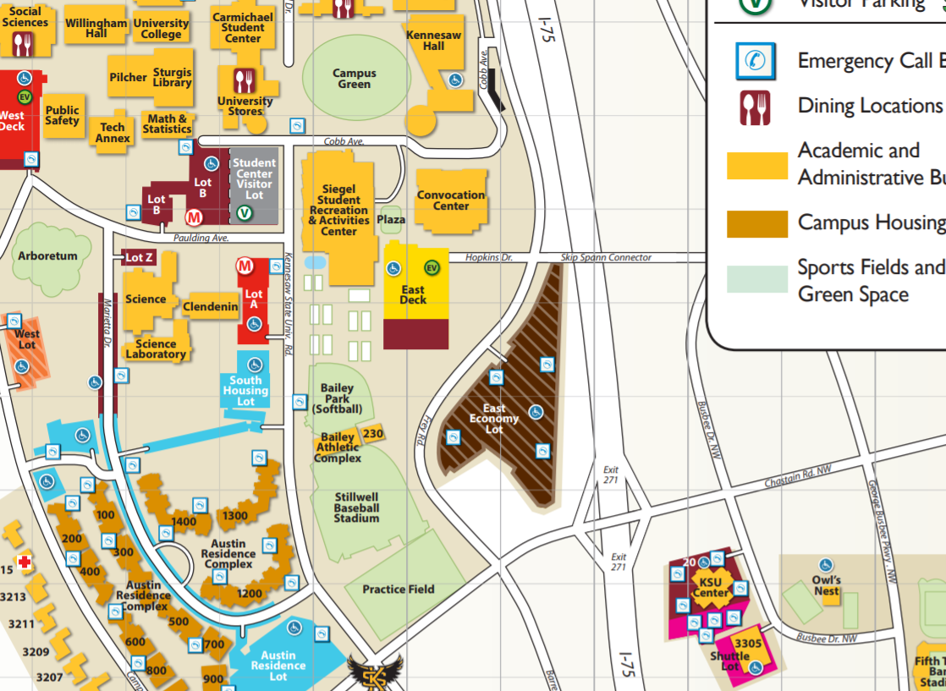
Events
Women’s Events | Stroke and Distance | Men’s Events
1 | 200 Medley Relay | 2
3 | 50 Fly | 4
5 | 200 Free | 6
7 | 50 Breast | 8
9 | 100 IM | 10
11 | 200 Fly | 12
13 | 100 Back | 14
15 | 50 Free | 16
17 | 200 Breast | 18
-- | 10 min break | --
19 | 400 IM/500 Free | 20
21 | 50 Back | 22
23 | 200 IM | 24
25 | 100 Free | 26
27 | 200 Back | 28
29 | 100 Breast | 30
31 | 100 Fly | 32
33 | 200 Free Relay | 34

